Problem Set 3 Solutions
(100 points)

Problem 1. Tulip Production (15 points).
- (10 points) Compute the marginal product of fertilizer for the different fertilizer quantities and plot the marginal product of fertilizer as a function of the quantity of fertilizer. Remember to use the initial point as reference (e.g., the marginal product of moving from 3 to 4 tons should be entered at the initial point of 3 tons).
To compute the marginal product of fertilizer, we use the formula: ${MP}_{F}=\frac{∆Q}{∆F}$, where F refers to fertilizer. The Table below indicates the marginal product of fertilizer for each quantity, and the graph below plots the marginal product of fertilizer as a function of the quantity of fertilizer.

Tons of fertilizer per month | Number of tulips per month | Marginal Product
0 | 0 | 500
1 | 500 | 600
2 | 1100 | 600
3 | 1700 | 500
4 | 2200 | 300
5 | 2500 | 100
6 | 2600 | -100
7 | 2500 | -500
8 | 2000

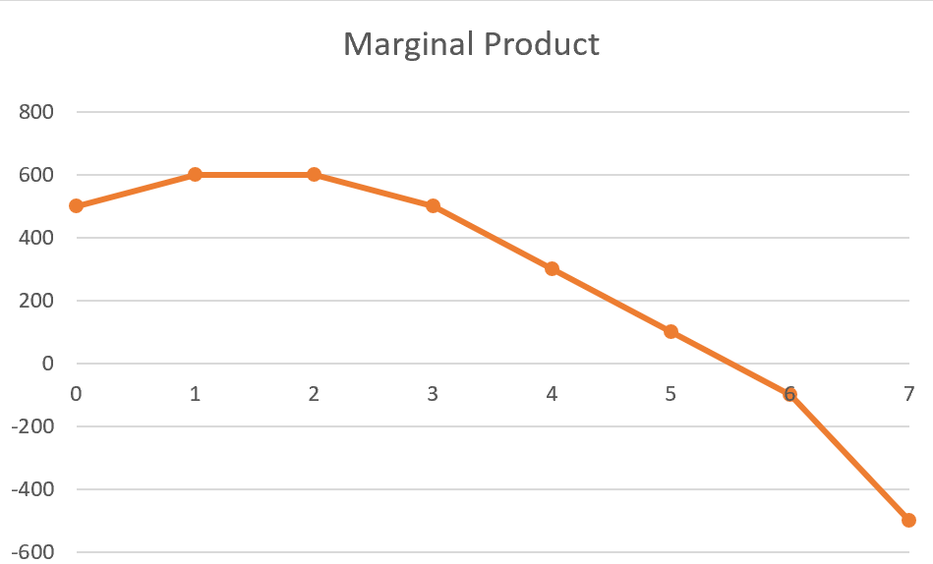

Tons of fertilizer

- (3 points) Does the production function exhibit diminishing marginal returns to fertilizer? If so, over which range of fertilizer quantity do they occur?

Yes, because as we move beyond the production of 2 tons, the marginal return to fertilizer is decreasing. [it is also fine to say “as we start producing the 3rd ton,” since production of the 3rd ton starts as soon as we move beyond the initial point of 2 tons]

- (2 points) Does total output always increase as more fertilizer is added?
No, from 6 to 8 tons total output decreases as more fertilizer is added.

Problem 2. Sludge Production (15 points).
A bottling company uses two inputs to produce bottles of the soft drink Sludge: bottling machines (K) and workers (L). The machine costs $1,000 per day to operate and the workers earn $200 per day. At the current level of production, the marginal product of the machines is an additional 200 bottles per day and the marginal product of labor is 50 more bottles per day.
- (8 points) Is this firm producing its output at minimum cost? Is this firm producing its output in an optimized way? If so, say why. If not, explain in which direction the firm should change its quantity of machines and workers to optimize its production.

When optimizing its input mix, the firm should equate the ‘bang’ for the buck for labor and capital: MP_{L}/w=MP_{K}/r. Here, MP_{L}/w=50/200=0.25 while MP_{K}/r=200/1000=0.2, so the firm is not minimizing costs. The firm should use fewer machines (to drive up MP_{K}) and more labor (in order to drive down MP_{L}). Another way to say this is the firm gets more "bang for the buck" from using labor relative to capital, so it should use more labor and less capital until the "bang for the buck" across factors is equalized.

When optimizing its input mix to produce a fixed output quantity, the firm should divide each input’s marginal product by that input’s marginal cost (their prices, which here are constant) and choose inputs so that these ratios are equal across inputs: MP_{L}/w=MP_{K}/r.

Here, MP_{L}/w=50/200=0.25 while MP_{K}/r=200/1000=0.2, so the firm is not minimizing costs. The firm should use fewer machines (to increase MP_{K}) and more labor (in order to reduce MP_{L}. This condition says the additional output you get per extra dollar spent should be the same no matter which input you spend the next dollar on; otherwise, you could reallocate spending toward the input that yields more extra output per dollar and reduce total cost for the same output. At the optimum input mix, no such cost-reducing substitution is left.

- (7 points) How does this relate to the idea of “bang for the buck” that we saw in class? Briefly illustrate in a short paragraph this concept with an example from your own experience/industry (no need to use actual numbers or real facts, you can use hypothetical scenarios if you wish).

In other words, when optimizing its input mix, the firm should equate the ‘bang’ for the buck for labor and capital, which is how the formula used above was called in class. The interpretation is that the firm gets more "bang for the buck" from using labor relative to capital, so it should use more labor and less capital until the "bang for the buck" across factors is equalized.

[Below an example of how the student could use their own industry to illustrate this concept]

A real-world example is the fast-food industry’s move from cashiers to self-service ordering kiosks (totems). Restaurants compared the service each extra dollar on staff cashiers delivered with the service each extra dollar spent on kiosks delivered. When kiosks provided more “orders handled per dollar,” many chains reallocated resources from cashiers toward kiosks until the extra service per dollar spent became more balanced between the two. They did not switch entirely to kiosks because some tasks would be too costly to be performed only by machines — such as handling special requests, or solving problems when machines fail — and for which the product of a human worker would still provide more “bang for the buck”.

Problem 3. Baseball Bats and Costs (25 points)
- (10 points)
Output | Total Cost | TFC | TVC | AFC | AVC | ATC | MC | TR | MR | Profit
0 | 25600 | 25600 | 0 |  |  |  | 5.8 | 0 | 6.4 | -25600
1000 | 31360 | 25600 | 5760 | 25.6 | 5.8 | 31.4 | 4.6 | 6400 | 6.4 | -24960
2000 | 35920 | 25600 | 10320 | 12.8 | 5.2 | 18.0 | 3.6 | 12800 | 6.4 | -23120
3000 | 39520 | 25600 | 13920 | 8.5 | 4.6 | 13.2 | 2.9 | 19200 | 6.4 | -20320
4000 | 42400 | 25600 | 16800 | 6.4 | 4.2 | 10.6 | 2.4 | 25600 | 6.4 | -16800
5000 | 44800 | 25600 | 19200 | 5.1 | 3.8 | 9.0 | 2.2 | 32000 | 6.4 | -12800
6000 | 46960 | 25600 | 21360 | 4.3 | 3.6 | 7.8 | 2.2 | 38400 | 6.4 | -8560
7000 | 49120 | 25600 | 23520 | 3.7 | 3.4 | 7.0 | 2.4 | 44800 | 6.4 | -4320
8000 | 51520 | 25600 | 25920 | 3.2 | 3.2 | 6.4 | 2.9 | 51200 | 6.4 | -320
9000 | 54400 | 25600 | 28800 | 2.8 | 3.2 | 6.0 | 3.6 | 57600 | 6.4 | 3200
10000 | 58000 | 25600 | 32400 | 2.6 | 3.2 | 5.8 | 4.6 | 64000 | 6.4 | 6000
11000 | 62560 | 25600 | 36960 | 2.3 | 3.4 | 5.7 | 5.8 | 70400 | 6.4 | 7840
12000 | 68320 | 25600 | 42720 | 2.1 | 3.6 | 5.7 | 7.2 | 76800 | 6.4 | 8480
13000 | 75520 | 25600 | 49920 | 2.0 | 3.8 | 5.8 | 8.9 | 83200 | 6.4 | 7680
14000 | 84400 | 25600 | 58800 | 1.8 | 4.2 | 6.0 | 10.8 | 89600 | 6.4 | 5200
15000 | 95200 | 25600 | 69600 | 1.7 | 4.6 | 6.3 | 13.0 | 96000 | 6.4 | 800
16000 | 108160 | 25600 | 82560 | 1.6 | 5.2 | 6.8 |  | 102400 | 6.4 | -5760

Table 1 – Costs and Revenues

Note: Using the initial-point method, MC=5.8 at Q=11,000 tells us that each additional unit costs us $5.80 as we move from producing Q=11,000 (initial point) to Q=12,000 (end point).

Figures 1 and 2 plot the different cost curves (not required for full credit)
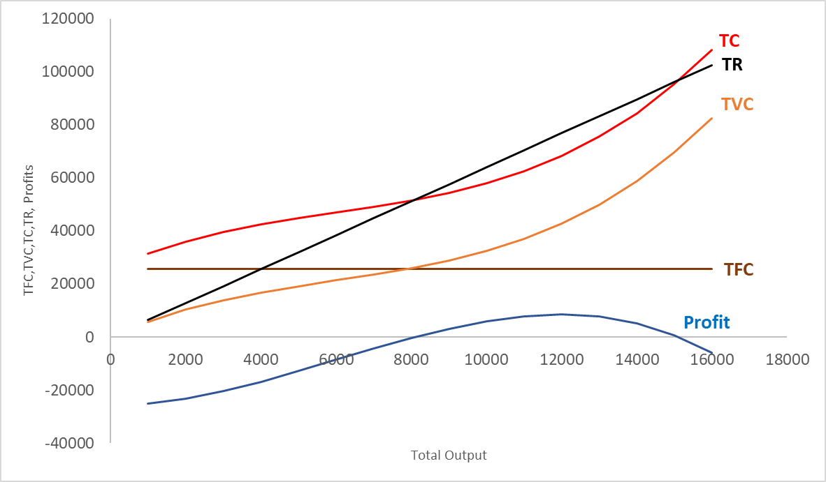

Figure 1 – TC, TVC, TFC, TR and Profit

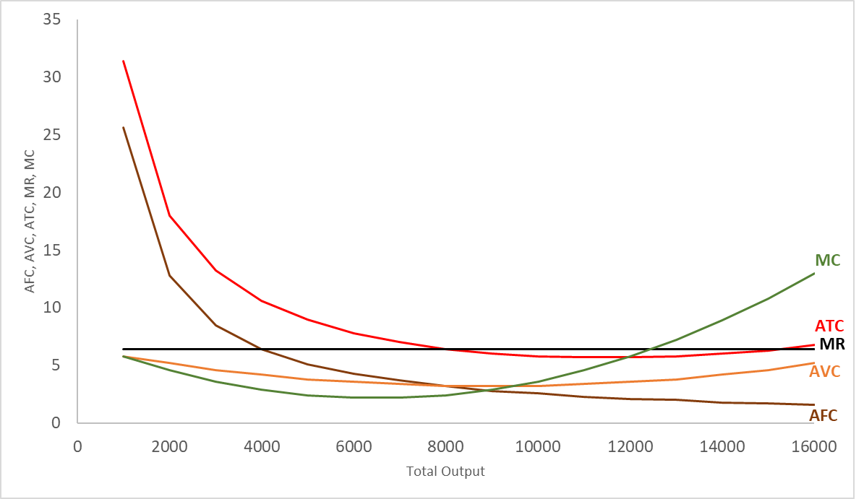

Figure 2 – ATC, AVC, AFC, MC and MR

- (5 points) Assuming that production can only be adjusted in steps of 1,000, what is the optimal output and what is the level of profits at this output level? If you could instead adjust quantity in smaller steps, would you produce (slightly) more or less in order to further raise profits (based on the comparison of MR and MC at the optimal output level you just reported)?

From Table 1 we see that profits are the highest for an output level of 12,000 which is thus the optimal output level. At this output level profits are equal to 8,480.
If production could be adjusted at a finer level, we would want to produce at a slightly lower level than 12,000. We know that at the optimum, MR=MC. At Q=12,000, MR=$6.4<$7.2=MC, which implies that the contribution to profit is negative and that we should produce (slightly) less. Hence the optimal Q that maximized profit is somewhat lower than Q=12,000.

- (10 points) Assume that the market price drops to $5.50. What is the new optimal level of output? Does the firm make a loss or a profit? Should the firm continue to produce in the short run at this new price? Continue to assume that production can only be adjusted in steps of 1,000.

We can reconstruct the same table as in question 1 but using a price of $5.50, thus adjusting the TR and MR columns (see below). Then, at a price of $5.50, the optimal output is 11,000, as this is where profits are the highest (or the least negative). At this output level, the ATC is greater than $5.50. Thus, at a price equal to $5.50 this firm would make a loss, after paying fixed costs. Nevertheless, at this output level, AVC is below the price. Thus, the firm should operate because it will contribute to cover its fixed cost.

Output | Total Cost | TFC | TVC | AFC | AVC | ATC | MC | TR | MR | Profit
0 | 25600 | 25600 | 0 |  |  |  | 5.8 | 0 | 5.5 | -25600
1000 | 31360 | 25600 | 5760 | 25.6 | 5.8 | 31.4 | 4.6 | 6400 | 5.5 | -25860
2000 | 35920 | 25600 | 10320 | 12.8 | 5.2 | 18.0 | 3.6 | 12800 | 5.5 | -24920
3000 | 39520 | 25600 | 13920 | 8.5 | 4.6 | 13.2 | 2.9 | 19200 | 5.5 | -23020
4000 | 42400 | 25600 | 16800 | 6.4 | 4.2 | 10.6 | 2.4 | 25600 | 5.5 | -20400
5000 | 44800 | 25600 | 19200 | 5.1 | 3.8 | 9.0 | 2.2 | 32000 | 5.5 | -17300
6000 | 46960 | 25600 | 21360 | 4.3 | 3.6 | 7.8 | 2.2 | 38400 | 5.5 | -13960
7000 | 49120 | 25600 | 23520 | 3.7 | 3.4 | 7.0 | 2.4 | 44800 | 5.5 | -10620
8000 | 51520 | 25600 | 25920 | 3.2 | 3.2 | 6.4 | 2.9 | 51200 | 5.5 | -7520
9000 | 54400 | 25600 | 28800 | 2.8 | 3.2 | 6.0 | 3.6 | 57600 | 5.5 | -4900
10000 | 58000 | 25600 | 32400 | 2.6 | 3.2 | 5.8 | 4.6 | 64000 | 5.5 | -3000
11000 | 62560 | 25600 | 36960 | 2.3 | 3.4 | 5.7 | 5.8 | 70400 | 5.5 | -2060
12000 | 68320 | 25600 | 42720 | 2.1 | 3.6 | 5.7 | 7.2 | 76800 | 5.5 | -2320
13000 | 75520 | 25600 | 49920 | 2.0 | 3.8 | 5.8 | 8.9 | 83200 | 5.5 | -4020
14000 | 84400 | 25600 | 58800 | 1.8 | 4.2 | 6.0 | 10.8 | 89600 | 5.5 | -7400
15000 | 95200 | 25600 | 69600 | 1.7 | 4.6 | 6.3 | 13.0 | 96000 | 5.5 | -12700
16000 | 108160 | 25600 | 82560 | 1.6 | 5.2 | 6.8 |  | 102400 | 5.5 | -20160
Table 2 – Costs and Revenues (at a price of $5.50)

Problem 4. Basketball Production (30 points)

a) (8 points) Under the old technology, what is the profit-maximizing output of Balding? What are profits at this output? Please explain how you obtained the profit-maximizing output and why following those steps makes sense. Here we want to know if you understand the concepts you apply, so avoid just solving a formula.
$MC_{o}=2+Q$.
To obtain optimal output, set $MC_{o}=P=MR=10$.
Thus: $2+Q=10$ → $Q_{o}=8$.
At this production volume, $TC_{o}=50+2⋅8+0.5⋅8^{2}=98$
Now compute profits: $Π_{o}=P⋅Q_{o}-TC_{o}=80-98=-18$

To choose the profit-maximizing output, one should compare marginal revenue (MR) to marginal cost (MC). In perfect competition, MR equals the market price, so here MR = 10 for every unit produced. If MR is greater than MC, producing an additional basketball increases profit, so the firm should expand output. However, MC rises as production increases, so it’s not optimal to produce indefinitely. Eventually, MC will catch up to MR. The point where MC = MR is exactly where the last unit produced adds just as much to revenue as it adds to cost. If the firm produces more than this, MC becomes larger than MR, meaning the extra units would reduce profit.

b) (3 points) Illustrate your answer to a) graphically. Show the point at which profit is maximized under the old technology, and the area representing the profits at the profit-maximizing output. You do not need to plot the exact functions; an illustration is fine. Just make sure to include all the relevant curves and to get their shape right. You may use AI tools to produce graphs.

The point at which profit is maximized is the point where MR and MC intersect. Given that Balding operates in a perfectly competitive environment, MR is equal to the market price, which is 10. From a) we have that $MC_{o}=2+Q$. Finally, to show the area representing the profits at the profit maximizing output, we need to represent the average total cost (ATC) curve. $ATC_{O}=\frac{TC_{O}}{Q}=\frac{50+2Q+0.5Q^{2}}{Q}=\frac{50}{Q}+2+0.5Q.$ The graph below plots the exact functions, but an illustration would have been fine.

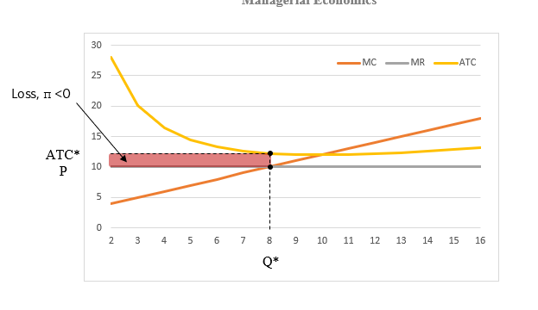

c) (8 points) If Balding cannot avoid paying the fixed cost of the old technology, should it continue to produce basketballs?
Despite the fact that Balding is making negative profits, it should continue to produce: AVC is below the price, so it makes a positive contribution to covering fixed costs. To see this, plug $Q=8$ into the expression for variable costs: $AVC=\frac{2Q+0.5Q^{2}}{Q}=\frac{16+0.5⋅8^{2}}{8}=6$. Thus, AVC<P.
d) (8 points) If Balding operated only the new technology, what would be the optimal output, and what would be its profits?
$MC_{N}=0.2Q$.
To obtain optimal output, set $MC_{N}=P=MR=10$.
Thus: 0.2$Q=10$ → $Q_{N}=50$.
At this production volume, $TC_{N}=100+0.1⋅{50}^{2}=350.$
Now compute profits: $Π_{N}=P⋅Q_{N}-TC_{N}=500-350=150$.

e) (3 points) Illustrate your answer to d) graphically. Show the point at which profit is maximized under the new technology, and the area representing the profits at the profit-maximizing output. You do not need to plot the exact functions; an illustration is fine. Just make sure to include all the relevant curves and to get their shape right.

The point at which profit is maximized is the point where MR and MC intersect. Given that Balding operates in a perfectly competitive environment, MR is equal to the market price, which is 10. From d) we have that $MC_{N}=0.2Q$, which is the equation of a line. Finally, to show the area representing the profits at the profit maximizing output, we need to represent the average total cost (ATC) curve. $ATC_{N}=\frac{TC_{N}}{Q}=\frac{100+0.1Q^{2}}{Q}=\frac{100}{Q}+0.1Q.$ The graph below plots the exact functions, but an illustration would have been fine.

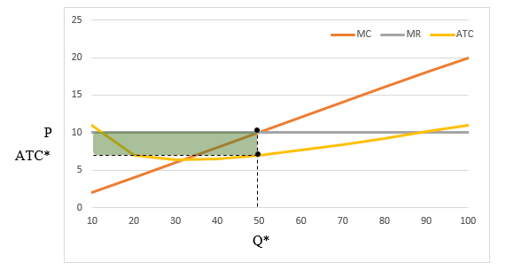
Profit, π >0

Problem 5. Taxing sugary drinks (25 points)
You are working in the campaign team of the governor of California. The governor would like to implement a tax on sugary drinks. You are asked the following:
- (10) What should be the amount of the tax (per ounce)? Try your best to make a recommendation. There is no right or wrong answer. We want to evaluate your reasoning based on the economic concepts learned in class. If you want more background on taxing sugary drink you can have a look at this article. You are encouraged to use your own experience/knowledge or use other references to (online) sources.
An externality is a cost or benefit that affects a third party that is not directly involved in an economic transaction. The two parties that are directly involved are consumers and sellers of sugary beverages. However, consuming sugary beverages is linked to diabetes and obesity. These conditions can impose an additional healthcare cost on society. Thus, there is an external cost or a negative externality associated with consuming sugary beverages. The goal of the tax on sugary drinks is to internalize this externality so that the marginal cost encompasses both the internal marginal cost (the marginal cost of the producers) and the societal marginal cost. The tax per ounce should thus be equal to the external marginal cost: the dollar value of the externality created by the consumption of one additional ounce of sugary drink.
According to the article “Diabetes cost the U.S. $327 billion in health care and lost productivity in 2017, according to the American Diabetes Association”. And the average economic cost per person is around $13,240 for diagnosed diabetes in 2017 (see https://www.ncbi.nlm.nih.gov/pmc/articles/PMC6702611/).
Moreover, A recent study indicates that replacing one daily serving of a sugary beverage with water, coffee, or tea was linked with a 2–10% lower risk of diabetes (see a summary of studies on the link between sugary drinks and diabetes here: https://www.hsph.harvard.edu/nutritionsource/healthy-drinks/sugary-drinks/).
Let’s assume that a daily serving size is the size of a regular Coca-Cola can: 12oz. This means that reducing the intake of sugary beverage by 12oz per day reduces the risk of diabetes by 2 to 10%. Let’s be conservative and assumes that it reduces the risk by 2%.
We can then compute the cost of one additional ounce of sugary drink as: (0.02*13,240)/(12*365)=0.06. The numerator represents the yearly cost to society of increasing sugary drink consumption by 12oz per day, and the denominator the total number of ounces this represents per year.
From this computation and under the assumptions state above, we can conclude that the tax on sugary drink should be equal to 6 cents per ounce.
Note: If the students assume that the tax will be proportional to the price and write an argument consistent with this assumption, full credit will be given.

- (8) Assume that the tax is levied on producers. How will the tax affect the equilibrium price of sugary drinks on the market? Illustrate your answer using a supply demand graph. You may use AI tools to produce graphs.

As illustrated in the graph below, when tax is added to the product, the supply curve shifts to the left, price increases from P to P’, and quantity decreases from Q to Q’.

S’ = S + tax

P
S

tax

$$P_{C}'$$

P

D
Q
Q
Q’

- (7) Who is more likely to bear the burden of the tax (and have the highest probability to vote for the governor’s opponent in the next elections)? How would your answer change if the tax is levied on consumers instead?

The tax burden will fall both on retailers and consumers, but the relative extent of the burden depends on the supply and demand elasticity. If consumers have high demand elasticity (in absolute value), consumers are very responsive to a change in price, a small increase if percentage change in price could lead to a high decrease in percentage change in quantity. In this case, the tax burden will be likely to fall more on retailers. On the contrary, if consumers have low demand elasticity (or demand is inelastic), they are not so responsive to a change in price, which means consumers are still willing to consume as much as they were before the price increase. In this case, the tax burden will be more likely to fall more on consumers.

For instance, the article (that was optional to read) indicates that the burden of the tax is likely to fall mainly on individuals living in low-income neighborhoods “where residents do not have the option of shopping at stores outside of the city limits in order to avoid the tax”. Due to the lack of substitutes, their demand is inelastic and they are thus likely to bear a large part of the tax burden.

The answer remains exactly the same if the tax is instead levied on consumers. Whether it is the consumers or the producers “sending the check” does not affect who ultimately bears the burden of the tax. It only depends on the supply and demand elasticities.

S’ = S + tax
P

S

$$P_{C}'$$

tax
P
$$P_{P}'$$

D

Q
Q
Q’

